1. Suppose that a data warehouse consists of the three dimensions time, doctor, and

patient, and the two measures count and charge, where charge is the fee that a doctor

charges a patient for a visit.

a. Draw a schema diagram for the above data warehouse using one of the

schemas. [star, snowflake, fact constellation]

b. Starting with the base cuboid [day, doctor, patient], what specific OLAP

operations should be performed in order to list the total fee collected by each

doctor in 2023?

Solution:

a.

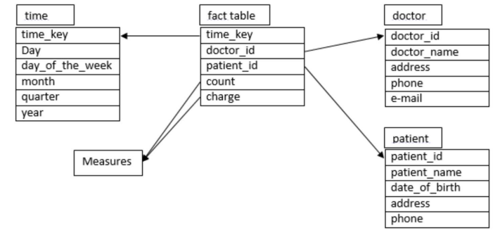

b.

First, we should use roll-up operation to get the year 2023(rolling-up from day

then month to year). After getting that, we need to use slice operation to select

(2023). Second, we should use roll-up operation again to get all patients. Then,

we need to use slice operation to select (all). Finally, we get list the total fee

collected by each doctor in 2023.

So,

1. roll up from day to month to year

2. slice for year = “2023”

3. roll up on patient from individual patient to all

4. slice for patient = “all”

4. get the list of total fee collected by each doctor in 2023

c. Ans

Select doctor, Sum(charge) From fee Where year = 2004 Group by doctor

2. Suppose that a data warehouse for Big-University consists of the following four

dimensions: student, course, semester, and instructor, and two measures count and

avg_grade. When at the lowest conceptual level (e.g., for a given student, course,

semester, and instructor combination), the avg_grade measure stores the actual

course grade of the student. At higher conceptual levels, avg_grade stores the

average grade for the given combination.

a. Draw a snowflake schema diagram for the data warehouse

b. Starting with the base cuboid [student, course, semester, instructor], what

specific OLAP operations (e.g., roll-up from semester to year) should one

perform in order to list the average grade of CS courses for each BigUniversity student

Ans:

a.

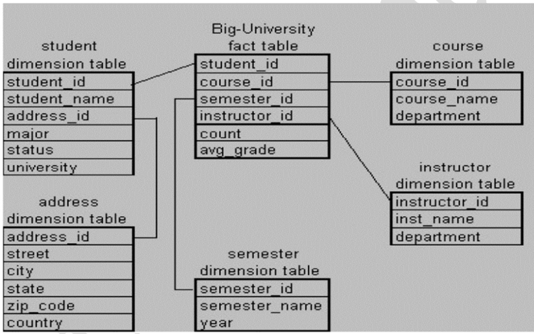

b. Ans

i. Roll-up on course from course_id to department.

ii. Roll-up on student from student_id to university.

iii. Dice on course, student with department ="CS" and university =

"biguniversity"

iv. Drill-down on student from university to student_name.